

Architecture Diagram and Labs User Stories

Globally Distributed App

Click2Cloud Inc.

Email: contact@click2cloud.net

Document Version – V1.0(Draft)

Contents

Overview 2

Proposed Architecture 3

LAB 1: 3

Problem Statement 3

Scenario 3

Technology Used 4

LAB 2: 4

Problem Statement 4

Scenario 4

Technology Used 5

LAB 3: 5

Problem Statement 5

Scenario 5

Technology Used 6

LAB 4: 6

Problem Statement 6

Scenario 6

Technology Used 7

LAB 5: 7

Problem Statement 7

Scenario 7

Technology Used 8

LAB 6: 8

Problem Statement 8

Scenario 8

Technology Used 9

# Overview

This document contents the proposed Labs and architecture for Globally distributed application on Immersion Labs.

Proposed lab would be called as; Globally Distributed Apps, one of the innovative strategy of Microsoft designed to deliver apps for FY18. Once the App would get ready, it would be used across the globe to validate Microsoft’s vision and strategy.

The globally distributed app would be an extension of the “ContosoAir.Com” demo, which is a customer facing app. The front end of the app code is available (can be used after some ticks) and entire backend would be developed from scratch. The app would be using majorly the COSMOS DB. Each lab should present different aspects of global distributed applications.

There would be total 6 labs around following technologies. Each can lab use a single or the combination of below mentioned technologies.

* COSMOS DB/MongoDB API/Graph API/Table API
* Azure Functions
* Cognitive Services
* BOT
* Logic App
* Bing Map
* Machine Learning
* Azure Search

Each lab to have its own user stories and should run in isolation with reference to another labs.

# Proposed Architecture

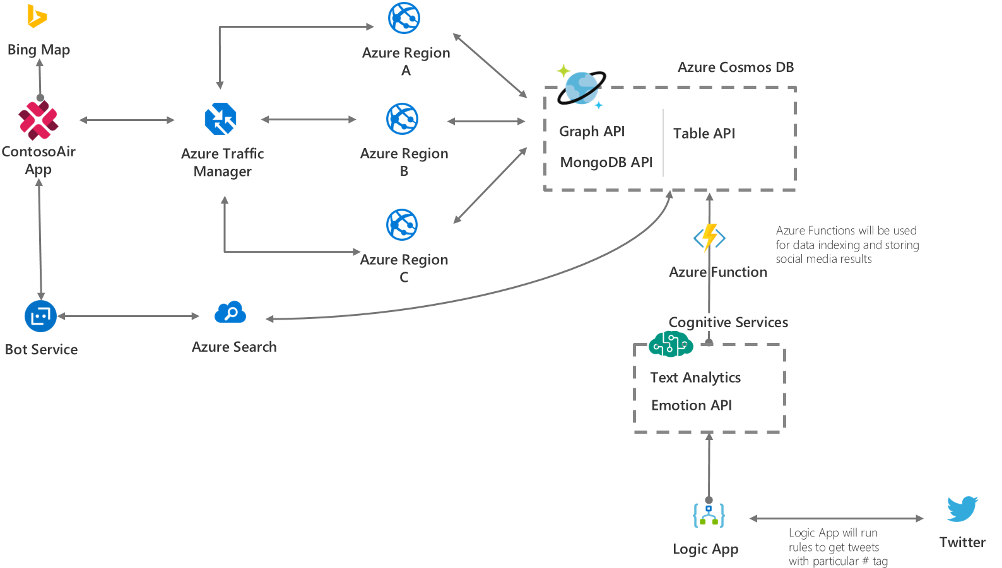

# LAB 1:

## Problem Statement

A ContosoAir customer is planning for vacation overseas and wanted to search for available location which doesn’t require VISA for travelling.

## Scenario

|  |  |
| --- | --- |
| 1 | Scenario walkthrough – Cosmos DB   1. Customer visit on contosair.com website for Air Ticket Booking. 2. Fill all the details required for Ticket Booking. 3. Enter Place name where he/she wants to visit. 4. It will display Place details whether it requires VISA or not and other details. 5. By clicking Find Other Placesbutton contosoair.com will display all places that doesn’t required VISA for selected citizen. |
| 2 | Scenario walkthrough – Bing Map API   1. After clicking on Find Other Places button contosoair.com will fetch all countries from CosmosDB Database. 2. And plot all fetched countries on Map using Bing Map API by Azure 3. Then user can also select other available places which does not required VISA 4. And Complete Ticket Booking Process on contosoair.com |

## Technology Used

Cosmos DB: It is used to store and retrieve data of countries for plotting it into the Bing Map

Bing Map: Bing Map service is used to Plot all the countries who doesn’t need VISA on Map

# LAB 2:

## Problem Statement

When customers want to travel by air, they book for specific airline. But, in a situation, they may experience that they are not going to travel with same airline, which they have booked for, but with a different airline. This happens because of codeshare, which is a business arrangement where two or more airlines share the same flight. To avoid customer inconvenience, they can check codeshare for booked airline by clicking Check Codeshare button and this will show all codeshare airline details of booked flight.

## Scenario

|  |  |
| --- | --- |
| 1 | Scenario walkthrough – Cosmos DB   1. Customer visit on contosair.com website for Air Ticket Booking. 2. Fill all the details required for Ticket Booking. Like TripType, From Date, To Date, Depart Date, Return Date & Passenger 3. It will list all available flights with their Airline Provider Name and fare. 4. Select flight appropriate flight as per need 5. By clicking Check Codeshare button user can see all available Codeshare for selected Airline provider. |
| 2 | Scenario walkthrough – Cosmos DB Graph (Gremlin) API   1. After clicking on Check Codeshare button, it will display codeshare. 2. Codeshare will display in graphical format by using Cosmos DB Graph (Gremlin) API. 3. And click on Book Ticket Button to complete Ticket booking process. |

## Technology Used

**Cosmos DB:** Cosmos DB is used to store and retrieve the Airline Codeshare.

**Cosmos DB Graph API:** Cosmos DB Graph API is used for display the codeshare airlines in graphical format.

# LAB 3:

## Problem Statement

A customer wants to travel to a tourist destination for an adventure. He/ She doesn’t aware more about the destination, to explore more about the destination he can take help of ContosoAir application and get an idea about the events and concerts happening during his/ her travel period, crime rates, climate situation etc.

## Scenario

|  |  |
| --- | --- |
| 1 | Scenario walkthrough – Cosmos DB, Logic App, Cognitive Services and Azure Function   1. The passenger logged-in into the Contosoair.com website. 2. The passenger will search for the flight where he/she wants to go. The cotosoair.com helps passenger to find the flights in the best rate with all the comfort. 3. The passenger will book the flight from location ABC to location XYZ. 4. After choosing the destination, the overall rating about that location is displayed on the website. 5. The Logic App will be configured to run in background which will continuously populate the tweets regarding the places. The tweets will be processed using Text Analytics of cognitive services for the sentimental analysis. It will keep the result in the Cosmos DB with the help of Azure functions. 6. The report will be shown to end customer while booking the tickets. So, that he/ she can judge the overall situation and plan the trip. 7. After booking the flight from location ABC to XYZ, the daily tweets about the location will be mailed to the user so that customer will be aware of the current situation. |

## Technology Used

Cosmos DB, Logic app, Cognitive Services (Text Analytics), and Azure function

# LAB 4:

## Problem Statement

The customer is driving towards the airport and gets stuck in traffic, now there are chances that he may miss the important flight.

So, to get the timely information he communicates with Azure bot service to know the status of his flight, as well as boarding gate number.

For that, bot will ask some question to the user like his flight number and will check with Cosmos DB to send appropriate information about the flight and boarding gate number which help him to reach as early as possible at the airport, the bot also send Bing map link of airport to find the shortest path or alternate to reach the airport. Once he reaches the airport the bot also send the terminal internal map to the user.

## Scenario

|  |  |
| --- | --- |
| 1 | Scenario walkthrough – Chat Bot   1. User booked the flight ticket from contosoair.com portal. 2. User booked cab to reach the airport. 3. While traveling toward the airport, he may get late to reach the airport because of traffic or some other problem. 4. The bot will interact will user and collect the information about the flight. 5. The bot will communicate with Cosmos DB using collected information from user. 6. The bot will send the flight status and boarding gate number to the user which will help the user to reach the airport as early as possible. |
| 2 | Scenario walkthrough – Bing map / Internal map view   1. The bot will send the airport map link. 2. Once user click on that link, Bing map will open with default airport location. 3. User will locate the route in the map and find the shortest path to reach the airport. |
| 3 | Scenario walkthrough – send terminal overview image   1. Once user reach the airport, the bot service will send the terminal internal map. 2. User will locate the gate number to reach the terminal as early as possible. |

## Technology Used

Bing map, Bot Services, Cosmos DB

# LAB 5:

## Problem Statement

Traditionally, it takes a long time and a lot of tedious effort to build a globally distributed database and there will be some issue like latency and consistency if the data stored in centralized location. So, to solve this we will use Azure Cosmos Database.

## Scenario

|  |  |
| --- | --- |
| 1 | Scenario walkthrough – Latency  Latency is the delay between a client request, probably a request made by you at your computer, and a response to that request.   1. The Developer runs an application of ContosoAir. 2. This application will get deployed in one region. 3. The developer than try to access the application and do all the operation like searching and booking a ticket and so on. 4. After that, the developer again change the region where application is deployed with   a region near to him/her and redeploy it.   1. The developer again repeat the same process of searching and booking a ticket and this time he/she will get a low latency. |
| 2 | Scenario walkthrough – Consistency Level  Different regions have their own copy of database, and they may not always be consistent if read / write operations happen frequently.   1. There is a possibility where another user book the same seat from another region which is already booked recently. 2. So, the user from this region should be aware about this changes. 3. So, to test this scenario developer can deploy this application in two different regions and browse the application and will try to book an air ticket for a seat. 4. After that, the developer will open another application deployed in another region and will try to book an air ticket for a same seat. 5. Developer can set the different consistency level of the cosmos database to see the impact of the how frequently the data updates. |

## Technology Used

ComosDB with MogoDB API

# LAB 6:

## Problem Statement

Flight delay is one of the most remembered performance indicator of any transportation system. When a customer wants to travel from Seattle to Barcelona, if he book the ticket with one the of Airline companies who is having the bad record for the flight delays to Barcelona. It may put a person in a trouble. This can be resolved through SparkDB and Machine Learning service of Azure.

## Scenario

|  |  |
| --- | --- |
| 1 | Scenario walkthrough – ContosoAir Website   1. The user goes to ContosoAir website. 2. User selects the Airline with which he/she wants to travel, Enter the details of source and destination under ticket booking section and clicks on the Delay prediction button. |
| 2 | Scenario walkthrough – Spark DB   1. After clicking on the Delay prediction button, it will fetch the data from SparkDB database which will be processed through machine learning service of Azure. |
| 3 | Scenario walkthrough – Machine Learning   1. Fetched data from SparkDB database will processed by rules defined in the machine learning service of the Azure for predicting the flights status; whether it will be delayed or not. 2. According to the predictive result, user will decide to book the ticket with that Airline or not. |

## Technology Used

Spark DB, Machine Learning